Stow Pool Housewarming Gathering - May, 2021

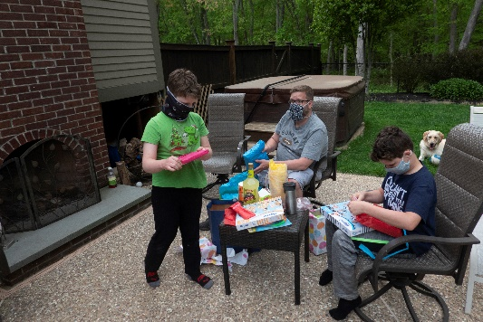This Spring, the Dave, Michelle, Greyson, and Silas Fauxes decided to relocate to a new home in Stow. All thoughts considered; the rest of the Faux clan decided to focus a housewarming “welcome” on necessities for their new pool. So, after lively conversations on Slack and excellent coordination by Jennifer, the “necessities” were presented to the new homeowners.

And for the photos, click on the [Pool Necessities](https://photos.app.goo.gl/7ZJbzhhkDyc3FMQv6) and feel free to enlarge.